plt.plot(f[:300], P[:300]) 🡨This stopped working for me for some reason so I moved to what I was familiar with – MATLAB ☺

What I did:

1. Run LFP_Filtering.py (on cluster)
   1. Selected EMG channels to [24,25]
2. Run LFP_Trial_Parsing.py
   1. Digital input channels were:
      1. 0: 90 Trials (30 NaCL (15 first/15 last), 60 LiCl)
      2. 1: 30 Trials (30 Water)
   2. Durations:
      1. Pre-Stimulus: 2000ms
      2. Post-Stimulus: 5000ms
   3. Delete Raw LFP data:
      1. Yes
3. [Fast Fourier transform](https://en.wikipedia.org/wiki/Fast_Fourier_transform) (FFT):
   1. Use this code:

#Import necessary tools

import numpy as np

import tables

import matplotlib.pyplot as plt

from scipy import signal

from scipy.signal import periodogram

#Open up hf5 file

hf5 = tables.open_file('NM46_CTA_training_160929_130610_repacked.h5', 'r+')

#Import Data for Water and LiCl trials (Dig_in 0) and NaCl (Dig_in_1)

data = hf5.root.Parsed_LFP.dig_in_0_LFPs[:]

W1_data = hf5.root.Parsed_LFP.dig_in_0_LFPs[:,:15,:]

LiCl_data = hf5.root.Parsed_LFP.dig_in_0_LFPs[:,15:75,:]

W2_data = hf5.root.Parsed_LFP.dig_in_0_LFPs[:,75:,:]

NaCl_data = hf5.root.Parsed_LFP.dig_in_1_LFPs[:,:30,:]

NaCl_data1 = hf5.root.Parsed_LFP.dig_in_1_LFPs[:,:15,:]

NaCl_data2 = hf5.root.Parsed_LFP.dig_in_1_LFPs[:,15:30,:]

#Whole Trial Parsing

W1_data = hf5.root.Parsed_LFP.dig_in_1_LFPs[:,:15,:]

W2_data = hf5.root.Parsed_LFP.dig_in_1_LFPs[:,15:30,:]

NaCl_data1 = hf5.root.Parsed_LFP.dig_in_0_LFPs[:,:15,:]

NaCl_data2 = hf5.root.Parsed_LFP.dig_in_0_LFPs[:,75:,:]

LiCl_data = hf5.root.Parsed_LFP.dig_in_0_LFPs[:,15:75,:]

#LiCl Parse

LiCl_data_1_4 = hf5.root.Parsed_LFP.dig_in_0_LFPs[:,15:30,:]

LiCl_data_2_4 = hf5.root.Parsed_LFP.dig_in_0_LFPs[:,30:45,:]

LiCl_data_3_4 = hf5.root.Parsed_LFP.dig_in_0_LFPs[:,45:60,:]

LiCl_data_4_4 = hf5.root.Parsed_LFP.dig_in_0_LFPs[:,60:75,:]

#Get means based on electrodes (0 = num_electrodes, 1= num_trials, 2 =durations[0] + durations[1])

W1_data = np.mean(W1_data, axis = (0))

W2_data = np.mean(W2_data, axis = (0))

NaCl_data1 = np.mean(NaCl_data1, axis = (0))

NaCl_data2 = np.mean(NaCl_data2, axis = (0))

LiCl_data = np.mean(LiCl_data, axis = (0))

LiCl_data_1_4 = np.mean(LiCl_data_1_4, axis = (0))

LiCl_data_2_4 = np.mean(LiCl_data_2_4, axis = (0))

LiCl_data_3_4 = np.mean(LiCl_data_3_4, axis = (0))

LiCl_data_4_4 = np.mean(LiCl_data_4_4, axis = (0))

#FFTs

f, P = periodogram(data, fs = 1000.0, return_onesided=True)

f_W1, P_Water1 = periodogram(W1_data, fs = 1000.0, return_onesided=True)

f_W2, P_Water2 = periodogram(W2_data, fs = 1000.0, return_onesided=True)

f_NaCl1, P_NaCl1 = periodogram(NaCl_data1, fs = 1000.0, return_onesided=True)

f_NaCl2, P_NaCl2 = periodogram(NaCl_data2, fs = 1000.0, return_onesided=True)

f_LiCl, P_LiCl = periodogram(LiCl_data, fs = 1000.0, return_onesided=True)

f_LiCl14, P_LiCl14 = periodogram(LiCl_data_1_4, fs = 1000.0, return_onesided=True)

f_LiCl24, P_LiCl24 = periodogram(LiCl_data_2_4, fs = 1000.0, return_onesided=True)

f_LiCl34, P_LiCl34 = periodogram(LiCl_data_3_4, fs = 1000.0, return_onesided=True)

f_LiCl44, P_LiCl44 = periodogram(LiCl_data_4_4, fs = 1000.0, return_onesided=True)

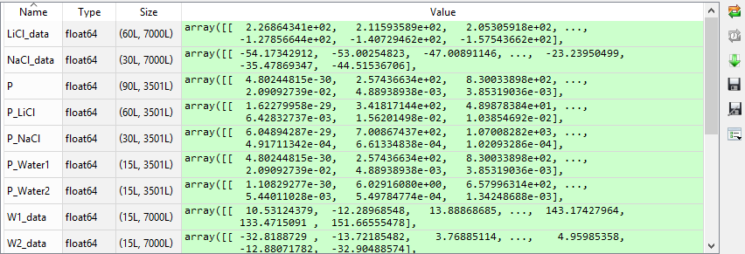

1. Save the data
   1. Click on the “Save data as…” button in Python
   2. Save data with whatever name you want with “*.mat” extension
2. Plotting
   1. Open MATLAB and use this code:

%load data

Change this to whatever you saved your data as.

load('Practice.mat')

%loop through PSD data to create averages across trials

for i=1:length(P_water1(1,:)),

P_water1(16,i) = mean(P_water1(1:length(P_water1(:,1)),i));

end;

for i=1:length(P_NaCl(1,:)),

P_NaCl(31,i) = mean(P_NaCl(1:length(P_NaCl(:,1)),i));

end;

for i=1:length(P_LiCl(1,:)),

P_LiCl(61,i) = mean(P_LiCl(1:length(P_LiCl(:,1)),i));

end;

for i=1:length(P_water2(1,:)),

P_water2(16,i) = mean(P_water2(1:length(P_water2(:,1)),i));

end;

Change this based on trials per tastes.

%Plot

plot(f_W1,P_water1(16,:));

hold on;

plot(f_NaCl,P_NaCl(31,:));

hold on;

plot(f_LiCl,P_LiCl(61,:));

hold on;

plot(f_W2,P_water2(16,:));

hold on;

yW1max = max((P_water1(16,:)));

yNamax = max((P_NaCl(31,:)));

yLimax = max((P_LiCl(61,:)));

yW2max = max((P_water2(16,:)));

ylim = max([yW1max,yNamax,yLimax,yW2max]);

axis([0 25 -1 ylim]);

xlabel('Power Spectral Density (mV^{2}/Hz)');

ylabel('Frequency (Hz)');

legend('Water 1 (15 Trials)','NaCl (30 Trials)','LiCl (60 Trials)','Water 2 (15 Trials)','Location','northeast');

1. Output

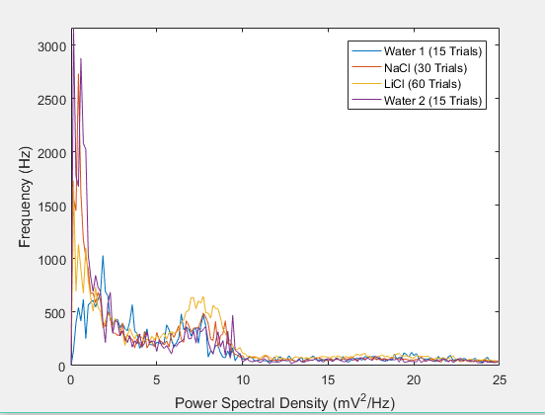

1. Output 2 (Separated NaCl trials)

%load data

load('Updated_NaCl1_2.mat')

%loop through PSD data to create averages across trials

for i=1:length(P_Water1(1,:)),

P_Water1(16,i) = mean(P_Water1(1:length(P_Water1(:,1)),i));

end;

for i=1:length(P_NaCl1(1,:)),

P_NaCl1(16,i) = mean(P_NaCl1(1:length(P_NaCl1(:,1)),i));

end;

for i=1:length(P_NaCl2(1,:)),

P_NaCl2(16,i) = mean(P_NaCl2(1:length(P_NaCl2(:,1)),i));

end;

for i=1:length(P_LiCl(1,:)),

P_LiCl(61,i) = mean(P_LiCl(1:length(P_LiCl(:,1)),i));

end;

for i=1:length(P_Water2(1,:)),

P_Water2(16,i) = mean(P_Water2(1:length(P_Water2(:,1)),i));

end;

%Plot

figure(200);

plot(f_W1,P_Water1(16,:));

hold on;

plot(f_NaCl1,P_NaCl1(16,:));

hold on;

plot(f_NaCl2,P_NaCl2(16,:));

hold on;

plot(f_LiCl,P_LiCl(61,:));

hold on;

plot(f_W2,P_Water2(16,:));

hold on;

yW1max = max((P_Water1(16,:)));

yNa1max = max((P_NaCl1(16,:)));

yNa2max = max((P_NaCl2(16,:)));

yLimax = max((P_LiCl(61,:)));

yW2max = max((P_Water2(16,:)));

ylim = max([yW1max,yNa1max,yNa2max,yLimax,yW2max]);

axis([0 25 -1 ylim]);

xlabel('Power Spectral Density (mV^{2}/Hz)');

ylabel('Frequency (Hz)');

legend('Water 1 (15 Trials)','NaCl 1 (15 Trials)','NaCl 2 (15 Trials)','LiCl (60 Trials)','Water 2 (15 Trials)','Location','northeast');

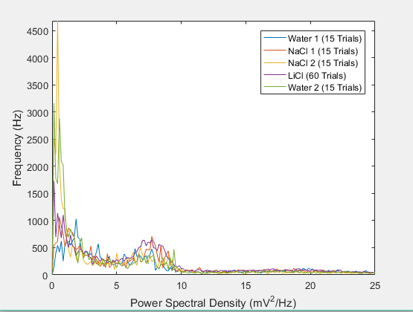

1. Output 3 (Single NaCl trials)

figure(200);

hold on;

plot(f_NaCl1,P_NaCl1(16,:));

hold on;

plot(f_NaCl2,P_NaCl2(16,:));

hold on;

yNa1max = max((P_NaCl1(16,:)));

yNa2max = max((P_NaCl2(16,:)));

ylim = max([yNa1max,yNa2max]);

axis([0 25 -1 ylim]);

xlabel('Power Spectral Density (mV^{2}/Hz)');

ylabel('Frequency (Hz)');

legend('NaCl 1 (15 Trials)','NaCl 2 (15 Trials)' ,'Location','northeast');

